* **What is Power BI?**

**Power BI** is a [business analytics](https://en.wikipedia.org/wiki/Business_analytics) service by [Microsoft](https://en.wikipedia.org/wiki/Microsoft). It aims to provide interactive [visualizations](https://en.wikipedia.org/wiki/Data_visualization) and [business intelligence](https://en.wikipedia.org/wiki/Business_intelligence) capabilities with an interface simple enough for end users to create their own reports and dashboards.

Power BI provides [cloud](https://en.wikipedia.org/wiki/Cloud_computing)-based BI (business intelligence) services, known as "Power BI Services", along with a desktop based interface, called "Power BI Desktop". It offers [data warehouse](https://en.wikipedia.org/wiki/Data_warehouse) capabilities including [data preparation](https://en.wikipedia.org/wiki/Data_preparation), [data discovery](https://en.wikipedia.org/wiki/Data_discovery) and interactive dashboards. In March 2016, Microsoft released an additional service called Power BI Embedded on its [Azure](https://en.wikipedia.org/wiki/Microsoft_Azure) cloud platform. One main differentiator of the product is the ability to load custom visualizations.

* **Power BI Desktop: Price- Free**

**Power BI Desktop** is a **free** application you install on your local computer that lets you connect to, transform, and visualize your data. With Power BI Desktop, you can connect to multiple different sources of data, and combine them (often called modeling) into a data model. This data model lets you build visuals, and collections of visuals you can share as reports, with other people inside your organization. Most users who work on business intelligence projects use Power BI Desktop to create reports, and then use the Power BI service to share their reports with others.

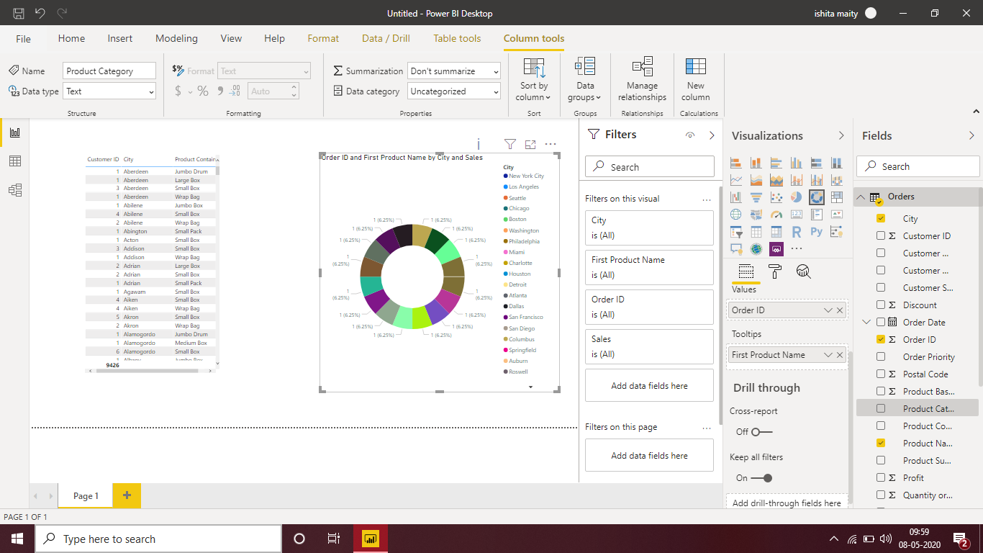

We can use the datasets imported in Power BI for data visualization and analysis by making sharable reports, dashboards, and apps. Power BI is a user-friendly tool offering impressive **drag-and-drop features** and **self-service capabilities**. A user can deploy Power BI on both on-premise and on cloud platforms.

In the image given below, have a look at the process flow in Power BI.

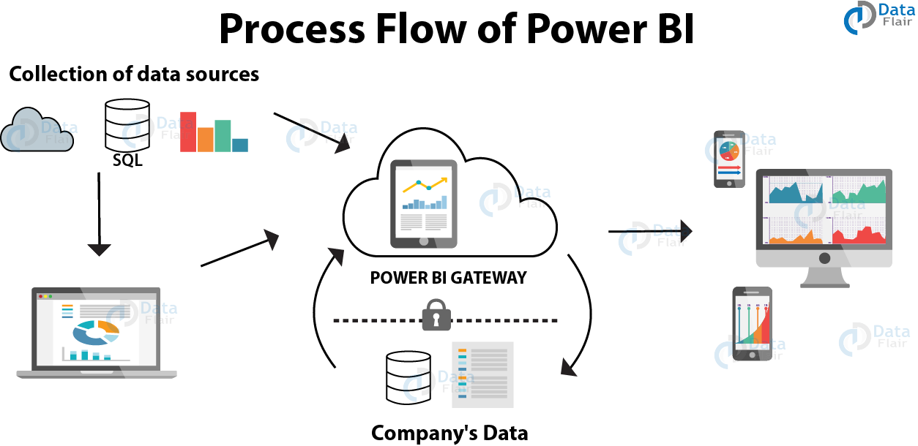

**Pros and Cons of Power BI Desktop:**

* **Affordable**

Power BI is a [cloud](https://www.techaffinity.com/cloud.html)-based business analytics service that gives you a single view for the dashboard to view your critical business data. Their paid version starts from just $9.99 per user per month. At this cost, you can’t find a better BI tool on the market today.

* **Microsoft Brand integration**

Since Power BI is developed by Microsoft it is tightly coupled with Microsoft product suite and hence integration with Excel, Azure and SQL server is a breeze. If you are an existing Microsoft business user of Azure or SQL server then integrating Power BI will be instant.

* **Consistent upgrades**

Power BI was launched in 2013 and since then it has gained so many new functionalities. Microsoft is very serious about Power BI and has recently introduced a range of new functionalities. Though Power BI might lack all the bells and whistles of matured BI tools in the market it will soon gain completeness in the future.

* **Easy integration with Excel**

Power BI is built on the same interface as Excel power, so if you’re an Excel power user then learning and using Power BI will be simple and straightforward.

* **Availability of huge learning resources and active community**

Microsoft Power BI has got a rich set of bloggers who constantly publish new tutorials and tips for using BI effectively. There are also numerous options for videos and slides offering tutorials on Power BI. In addition to these rich resources, there is a growing community of Power BI users with whom you can collaborate to find answers to Power BI problems.

* **Good report visualization**

Microsoft Power BI has an extensive range of charting options for visualizing your data. With multiple chart types, Power BI offers detailed reporting. Users can also generate customized visualizations.

* **Extensive Database connectivity**

Power BI can connect and extract data from a variety of data sources like Excel, Access, Adobe Analytics, SQL Server, Azure, Github, Google Analytics, Oracle, PostgreSQL, Salesforce, Teradata, etc. This is only a sample list with more and more data sources getting added each month.

* **Enhanced Collaboration**

Power BI dashboards and reports can be accessed across platforms anytime live. It works on all platforms like Windows, Android, and iOS. It is easy to share your customized dashboards with other users instantly.

* **Power BI Pro : Price- $9.99 per user, per month.**

Power BI Pro isn’t hugely different to Power BI Desktop. They have the same visualization options, the same limits on storage and file upload size, and the same report refresh allowance. The key difference is that with Pro, you can share your data, reports, and dashboards with others privately—provided they also have a Power BI Pro license.

There are a few other extras that come with the Pro license too. For example, with Pro you can create app workspaces, where you can put together collections of related dashboards and reports and create easily accessible content packs.

* **Power BI Premium : Price- $4,995 a month per dedicated cloud**

**Computing and storage resource**

Power BI Premium is the most expensive tier of Power BI currently available and very distinct from the other two versions available on the market.

On top of the features and functionality standard to all versions of the service, users of Power BI Premium get:

* Increased data capacity limits and maximum performance
* Access to one API surface
* Ability to embed Power BI visuals into apps (PowerApps, SharePoint, Teams, etc)
* Larger storage sizes for extended deployments
* Geo distribution, higher refresh rates, isolation, pin to memory, read-only replicas
* Power BI Report Server

Power BI Premium differs from the free version and Power BI pro in its licensing model, which only suits a specific size and type of organisation and business scenario. You can purchase Premium in a range of capacity sizes that offer different numbers of memory and virtual cores that can scale as your data analysis requirements change.

With Power BI Premium, you are licensing capacity for your datasets, dashboards and reports, not just licensing all users of that content. In other words, you’re not buying individual licenses, you’re buying them in bulk to allow a large number of your users to use Power BI to view reports. All of your content is stored in Premium and can then be viewed by as many users in your organisation as you want, without additional per-user costs.

**Power BI Pro vs Power BI Premium key differences**

Power BI Pro and and Power BI Premium's differences mostly come down to aforementioned performance - if you're using Premium, you will actually need to have a large number of users to make it worthwhile.

The reason is simple: Power BI Premium only lets your users consume Power BI content rather than actually create reports. Consume refers to viewing Power BI custom-built dashboards and reports published on the Web, Power BI mobile apps, or reports embedded in internally-developed applications ([such as PowerApps](https://xo.xello.com.au/blog/how-powerapps-builds-better-business-solutions)) and portals.

It’s important to understand that even with a Power BI Premium license, your organisation’s self-service BI users (i.e. the guys actually building reports and not just consuming them using Power BI) still require their own Power BI Pro licenses to create reports for consumption for the rest of your users (those just viewing) covered by Premium.

By having a Premium license, your smaller number of Pro users unlock more capacity (larger storage sizes) and higher limits (refresh rates, isolation, etc) - so it's not totally a case of only having one or the other - unless..